Unit 2 Northwind Front-End Screenshots and repository link

**Corey Crooks**

**Purdue University Global**

**IT481 – Advanced Software Development**

**Ahmad Kassem**

**May 3rd, 2023**

**Program at startup:**

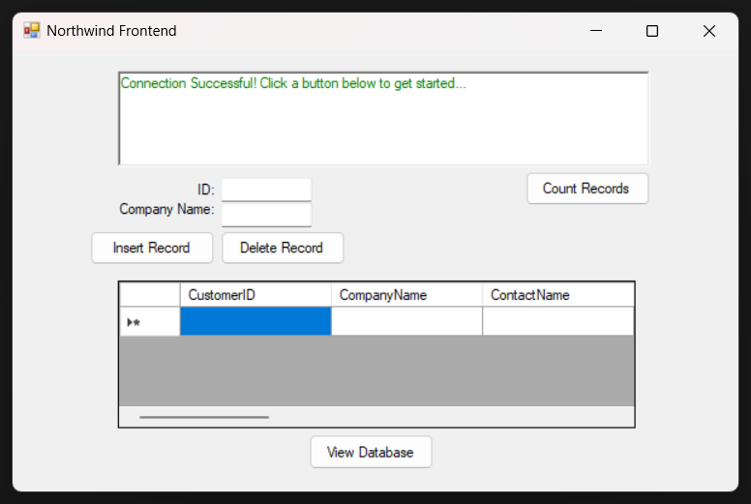

**Program when counting records:**

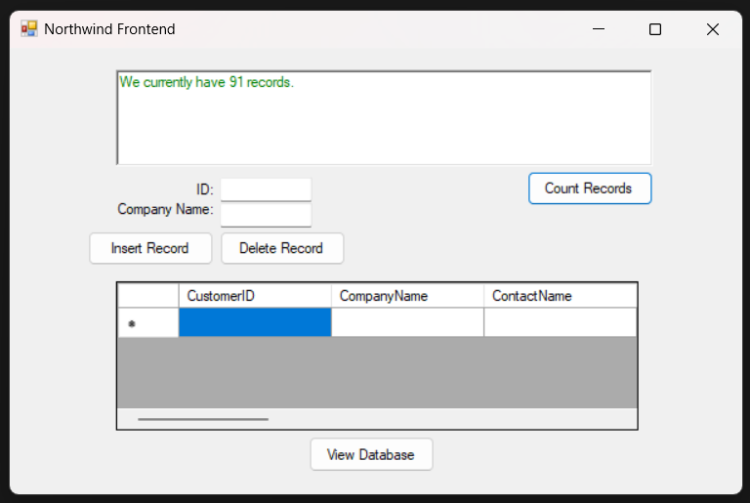

**Program when inserting a record:**

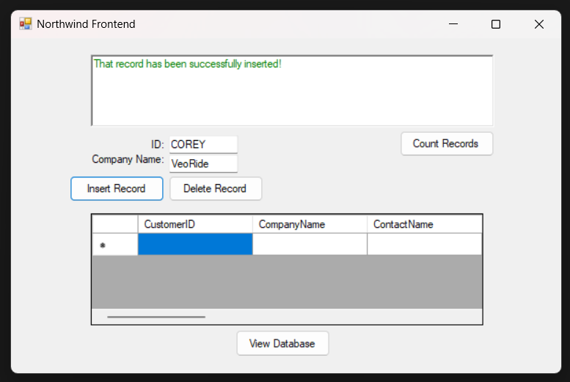

**Program when viewing the database (showing record insertion):**

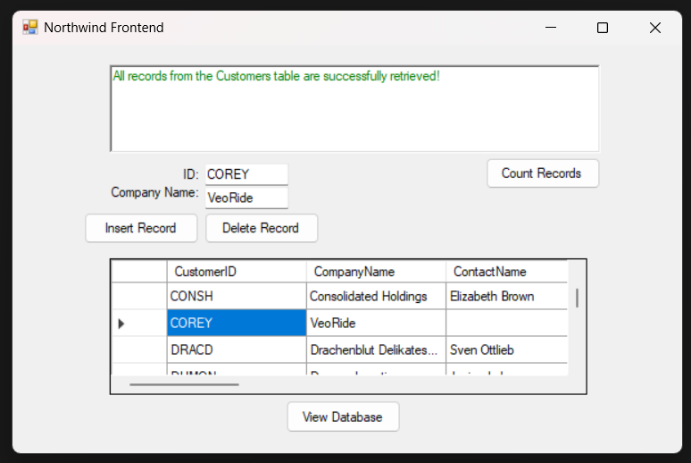

**Program when deleting a record:**

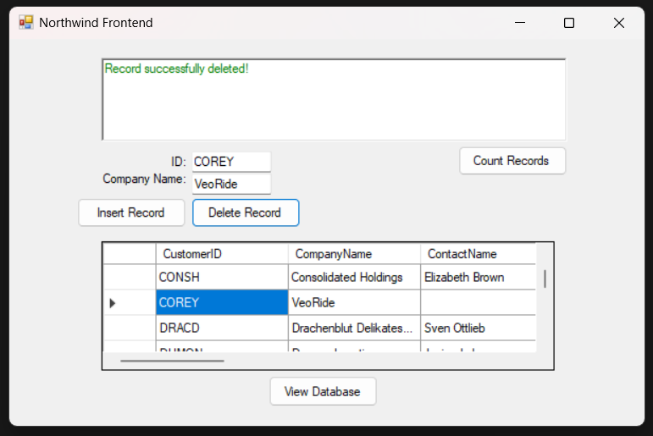

**Program when viewing the database (showing record insertion):**

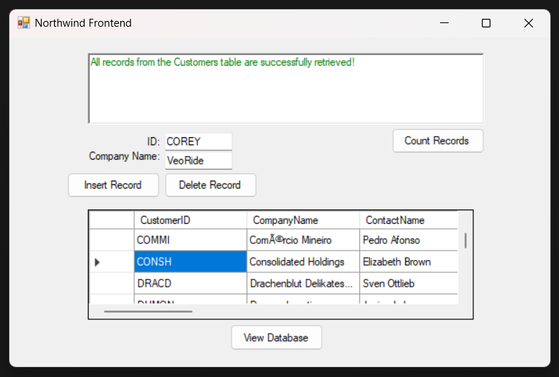

**Screenshot proof of upload to SCM (GitHub):**

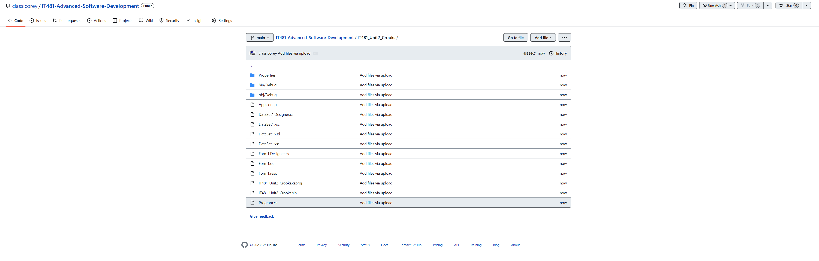

**URL:**

https://github.com/classicorey/IT481-Advanced-Software-Development/tree/main/IT481_Unit2_Crooks